|  |  |  |  |  |
| --- | --- | --- | --- | --- |
| EGC_Black | | Mathematics Essentials 2017  Unit 3/4 Test 4  Task Weighting: 8% | | |
| Student Name: |  | | TOTAL 57 Marks MmMarks |

Time Allowed: 10 Minutes Marks: 14

**Calculator Free** **No calculator or notes permitted for this section.**

### Question 1 (2 marks: 1, 1)

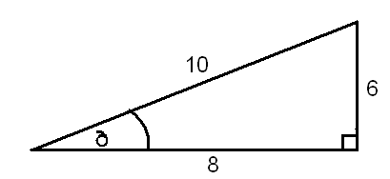Circle the correct answer in each of the following multiple choice questions

1. In relation to the angle, which is the opposite side?

### (i) 10 (ii) 8 (iii) 6 (iv) none of these

1. The value for *x* in the diagram is given by:

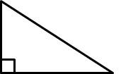

x

12

30˚

12\_\_

sin 30O

12\_\_

tan 30O

### (i) 12 x sin 30O (ii) 12 x cos 30O (iii) (iv)

**Question 2 (2 Marks)**

Express the probability of the following situation using the appropriate method shown:

Choosing a blue jellybean from a jar containing 7 red, 5 green and 4 blue jellybeans

1. Word \_\_\_\_\_\_\_\_\_\_\_\_\_\_\_
2. Fraction\_\_\_\_\_\_\_\_\_\_\_\_\_\_\_
3. Decimal\_\_\_\_\_\_\_\_\_\_\_\_\_\_\_\_
4. Percentage\_\_\_\_\_\_\_\_\_\_\_\_\_

**Question 3 (2 Marks)**

Provide a real life example/situation where probability is used to make a decision or decisions. Explain your answer

**Question 4 (1 Marks)**

Mines Rovers Colts have won 3 of their 12 games (as of round 15). What is their relative frequency of winning?

**Question 5 (3 Marks)**

Explain how you would determine the height of the tree using the information provided.

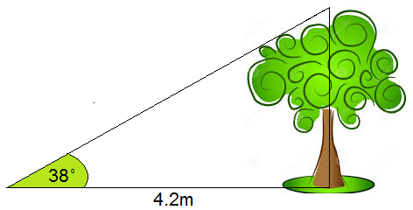

**Question 6 (2 Marks)**

Tomorrow’s weather forecast includes the statements: The probability of strong winds is 70%. The chance of rain is $\frac{4}{5}$. Which event, strong winds or rain is more likely to occur? Justify with calculations.

**Question 7 (2 Marks)**

Sketch and label the following scenario:

Liam is standing at the top of a lighthouse that is 22.8m tall. He looks down at a boat at an angle of depression of 32˚

End of Calculator Free Section

Time Allowed: 40 Minutes Marks: 43

**Calculator Assumed - Calculators and files are allowed in this test.**

***Show all working to maximise marks.***

**Question 8 (3 marks)**

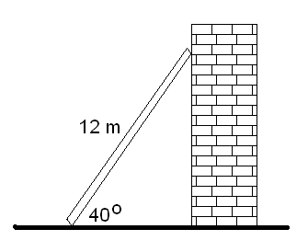A ladder 12 m long leans against a wall. If it forms an angle of 400 with the ground, how far is the bottom of the ladder away from the wall?

**Question 9 (5 Marks)**

Brodie **ALWAYS** orders from the following items when he eats at McDonalds; a Big Mac or a Quarter Pounder to start, then either a Chocolate, Caramel or Strawberry Mega Choc Waffle Cone and finally either a Coke or Fanta to wash it down.

If Brodie goes to McDonalds twice a week for 3 weeks how many Chocolate Mega Choc Waffle Cones would you expect Brodie to eat? Justify by demonstrating the sample space.

**Question 10 (7 Marks: 2, 1, 1, 3)**

In basketball a player can shoot one of 3 shots; a 2 pointer (worth 2 points), a 3 pointer (worth 3 points) or a Free Throw (worth 1 point). A player’s shooting percentage is the probability of making that shot.

If Maui has a 2-Point field goal percentage of 46%, a 3-Point field goal percentage of 30% and a Free Throw percentage of 80%. Calculate:

1. How many Free Throws would you expect to be successful from 56 shots?
2. How many 2-Pointers would you expect to be successful from 21 shots?
3. How many 3-Pointers would you expect to be successful if 15 were shot?
4. Dion rates himself as a 3-point shooter (3-Point field goal percentage of 35%) but Maui thinks differently. Maui challenges Dion to a shootout and says that with 20 shots he could outscore Dion by shooting only 2 pointers, with Dion only shooting 3 pointers. Is he correct? Justify with calculations

**Question 11 (3 marks)**

A 25 m flagpole casts a 42 m shadow. What is the angle the sun makes with the flagpole

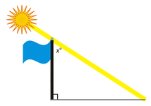

**Question 12 (4 marks)**

Below is the metal cross section for a frame of a shed. If the metal costs $14.65/m, how much would it cost to construct this part of the frame?

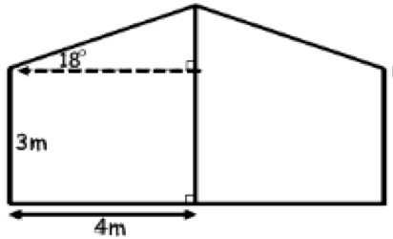

**Question 13 (10 Marks 1, 2, 3, 2, 2)**

Supposing that Ebola has a 70% fatality rate for those infected.

1. If there are 20 people in a hospital currently being treated for Ebola, how many of those people would you expect to die?
2. In an African village that has 15 people infected with the virus, how many of these are expected to survive?

You are studying the 20 people in hospital with the virus and want to conduct a simulation to determine what will happen to them.

1. Describe in detail how you could set up a simulation. For each person, how will you determine whether or not they die?
2. How many trials of the simulation would you run? Explain your reasons.
3. Does this simulation guarantee to give you an accurate picture of what will happen? Explain.

**Question 14 (7 Marks: 2, 2, 2, 1)**

This game is based on tennis but uses a coin and a six-sided die. There are two players, A and B. A serves by tossing a coin. If the outcome is heads (H) the service is good; if tails (T) there is a fault and that player is allowed to serve again. Only two services are allowed. H or TH gives a good service; TT gives a double fault, and B wins the point.

If the service is good, B rolls the die.

If the outcome is 1, 2, 3, or 4 then it is a good stroke; if 5 or 6 then the point is lost.

If the stroke is good then A rolls the die. This continues until the point is lost.

**Pete is playing Mark in a game of Rainy Day Tennis.**

a) Pete is serving. He tosses the coin and gets a head. He then tosses the coin again and gets another head. Mark says that Pete is playing the game incorrectly. Explain why.

b) The following results of tossing the coin and rolling the die were recorded for a game:

T H 3 1 4 2 6

Explain who won, given that Pete served. Explain your answer

c) If neither player had a coin, but they had the die, explain a method that could be used to play the game so that it is basically the same as in the rules.

d) State one factor that may cause this simulation to no longer model the real world event.

**Question 15 (4 marks)**

“Odds On” is a game in which you set a dare and then each player picks a number from 1 to an agreed upon maximum number. The person has to complete the dare if either, both players say the same number, or if both numbers add up to the maximum number.

If you were challenged to do a dare with the maximum number being 3, what number should you pick to minimise the chances of you having to do the dare? Use the grid provided and justify your answer

|  |  |  |  |
| --- | --- | --- | --- |
|  |  |  |  |
|  |  |  |  |
|  |  |  |  |
|  |  |  |  |

End of Test